FHIR Server Implementation Assignment

C# server implementation – Operations Guide
Note: - I am not familiar with Java or Node JS at all. Therefore, I implemented a server which is a basic http listener which will cater for Patient, Practitioner and Medication Request profiles.

- Set Start up project as “fhir-server-CSharp” by right-clicking the project and select “Set As Startup Project”

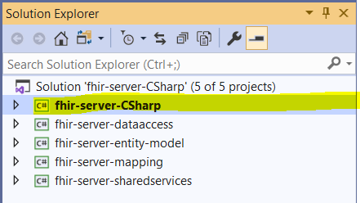

- Listener is listening on port 5834 for any incoming HTTP traffic. If your machine is using this port, change it to a different port. You can change this by modifying appsettings.json configuration file which can be found in “fhir-server-CSharp” project.

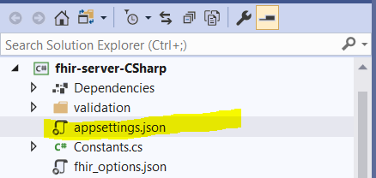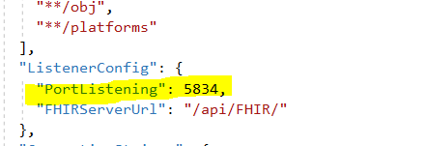

- A CapabilityStatement has implemented and that defines all operations which can be performed against this server.

- I bundled all the queries in “FI-W03-FHIR-SERVER-EN-r4-C#.postman_collection.json” postman file, so it is easy for you to access the functionalities of this server.

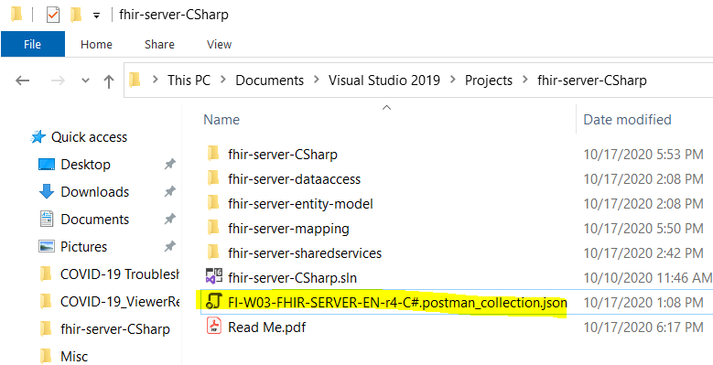

- This server supports POST MedicationRequest JSON data validation by utilizing the specification defined for US Core profiles. Nuget library has HL7.Fhir.Specification.R4 library for this and this server uses this library. This feature cannot be turned off because it is a MUST to validate user supplied data to make sure that the JSON payload contains proper cardinalities defined in US Core MedicationRequest profile (https://www.hl7.org/fhir/us/core/StructureDefinition-us-core-medicationrequest.html).

Also, GET validates bundles and resources as well. As the output profile validation takes some time, I disable that feature. You can enable the feature by modifying the appsettings.config and the following properties.

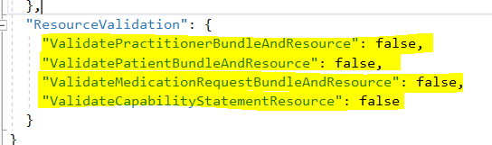

- Database has new tables for Medication Request and two new views. Please be sure to use the database provided with this solution.

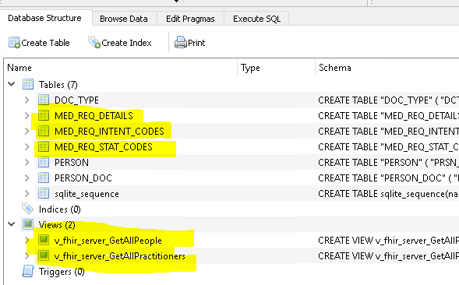

- This project is built using .NET Core framework 3.1 and Visual Studio 2019 is used as the IDE for all projects.

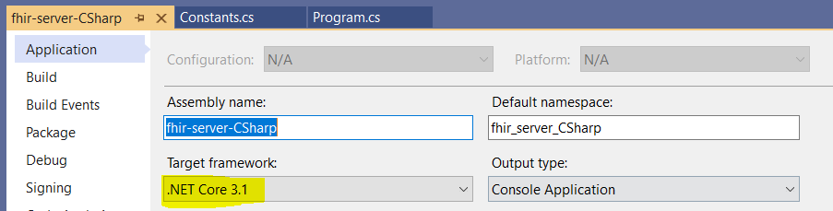

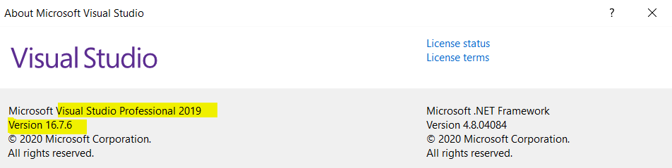

- PERSON, DOC_TYPE and PERSON_DOC table structures never changed as per the assignment requirement and I leverage the existing database/table structure to load Practitioners as well. As per the capability statement, Patient and Practitioner resources only supports READ. So if you wish to create new Patient and Practitioner resources, you could copy this database to NODE JS or JAVA project and run the application, create the resources as you want and then get the new database and replace the one which I have attached with this solution. If you wish to have POST feature for Practitioner and Patient in C# server, please let me know and I will put some time to implement that feature too.

- Finally, I put some real effort on creating this server using C# and I UNIT tested to eliminate all possible errors. I think I fulfilled all requirements asked in this assignment too. If you find any difficulties running this project please let me know and I will provide 100% support to run the project. You can contact me via Chandima.fonseka@ontariohealth.ca or Lakmal.asia@gmail.com.

